Optimization Lecture Notes – Week 8
5.1. GENETIC ALGORITHM
5.1.1. Introduction
Genetic algorithms (GAs) are search algorithms based on the mechanism of natural selection. These algorithms rely on one of the most fundamental principles proposed by Charles Darwin, known as the survival of the fittest. In general, a population undergoes many transformations. After several generations, when no significant change is observed in the population, the best individual is considered to represent the optimal solution.
Genetic algorithms mimic the genetic process in which hereditary traits are passed from parents to offspring. The basic unit of heredity is the gene. Many genes that encode specific characteristics (such as eye color, height, etc.) are located on a chromosome. For example, humans have 23 pairs of chromosomes. One chromosome in each pair comes from the mother and the other from the father. As a result of the crossover process, some characteristics of the parents can appear together in the offspring.
In the natural inheritance process, some genes may also undergo random mutation. For example, if the gene that determines eye color mutates, a child may have blue eyes even if both parents have brown eyes. Mutation introduces diversity into offspring and increases their chances of survival under changing environmental conditions.
In gradient-based methods, the solution is moved from one point to another using gradient and Hessian information. In contrast, genetic algorithms operate on a population rather than a single point. The fitness value (objective function value) of each individual in the population (which corresponds to a point in the search space) is calculated. Individuals with higher fitness values are subjected to crossover and mutation operations in the hope of producing better offspring. Here, “better offspring” refers to individuals with higher fitness values compared to their parents.
To enable genetic operators to be applied easily to the design variables (x), these variables are usually encoded as binary strings. After undergoing genetic operations, new values are obtained by decoding these binary strings. Using these new values, the fitness of each individual in the new population is calculated. This process completes one generation (iteration) of the genetic algorithm. The working principle of a genetic algorithm is generally illustrated using a flowchart (Figure 5.2).
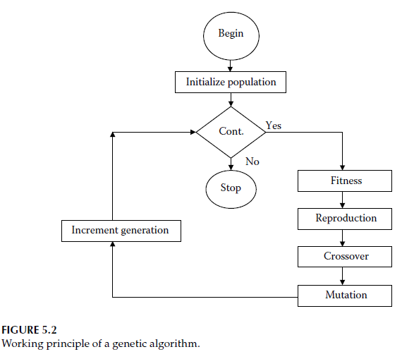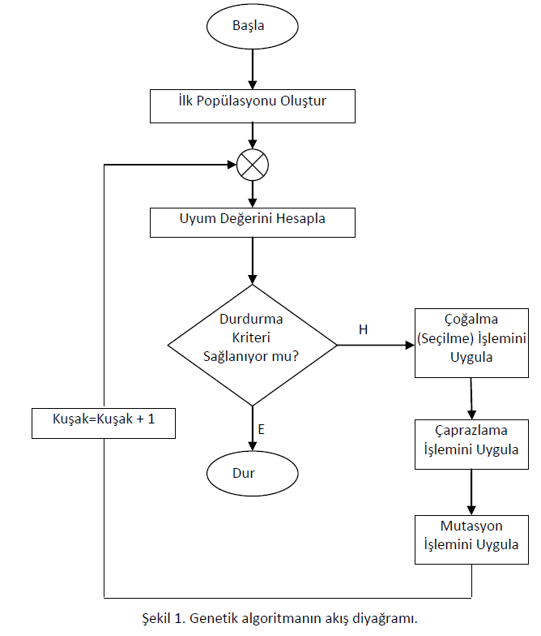
5.1.2. Why Genetic Algorithms?
Genetic algorithms are widely used today in many fields. They are especially preferred for optimization purposes in experimental studies, engineering applications, and industry.
Nowadays, genetic algorithms are effectively used in problems that have a wide application area, complex structures, limited prior knowledge, or where mathematical modeling is difficult or not feasible. They also provide an important alternative for problems where traditional methods fail to produce satisfactory results.
In addition to genetic algorithms, many other artificial intelligence-based methods are used today, such as Artificial Neural Networks, Tabu Search, Ant Colony Optimization, Particle Swarm Optimization, Differential Evolution, and Artificial Bee Colony.
Genetic algorithms are frequently preferred for solving multi-variable problems that are difficult for traditional algorithms. The main reason is that they can provide faster and simpler solutions. By encoding complex structures into simple bit strings, genetic algorithms simplify the problem-solving process.
Classical methods used for solving complex problems include gradient-based methods, linear programming, quadratic programming, interior-point methods, and the Newton-Raphson method. However, these methods may suffer from issues such as getting stuck in local optima.
If a problem is non-differentiable, non-convex, or nonlinear, genetic algorithms can often yield better results, i.e., global optimum solutions. Additionally, genetic algorithms tend to improve the initial population in each generation and converge toward the optimal solution over time.

5.1.3. Structure and Working Principle of Genetic Algorithms
The working principle of genetic algorithms is based on the process of biological evolution. These algorithms start with an initial population and improve it in each iteration (generation) to produce better solutions.
The main steps are as follows:
- Initialization of the population
- Calculation of fitness values
- Selection
- Crossover
- Mutation
- Formation of a new population
These steps are repeated until a stopping criterion is satisfied. At the end of the process, the best individual obtained is considered the optimal solution to the problem.

5.1.3.1. Encoding
Encoding is the process of transforming problem-specific information into a format suitable for use in a genetic algorithm. Each problem may require a different encoding scheme, and there is no single universal encoding method applicable to all problems.
Encoding types can be classified into three main groups:
Binary Encoding
This is the most commonly used encoding method. Possible solutions of the problem are represented using binary digits (0 and 1).
Permutation Encoding
This type is generally used in combinatorial optimization problems. The fitness of a sequence depends not only on gene values but also on their order. Problems such as the Traveling Salesman Problem and Vehicle Routing Problem are suitable for this encoding.
In the Traveling Salesman Problem, each integer represents a city. This method prevents repetition of values and simplifies the calculation of fitness values.
For example:
X = [4 3 0 1 2]
This sequence represents visiting the fourth city, then the third city, then the central city, followed by the first and second cities.
Value Encoding
In value encoding, each chromosome consists of a set of values. These values can be numbers or characters depending on the problem.
Examples:
- A = 1.2324, 5.3243, 0.4556, 2.3293, 2.4545
- B = ABDJEIFRGT
- C = (back), (back), (right), (forward), (left)
Value encoding is particularly useful for certain specialized problems. However, when this encoding is used, problem-specific crossover and mutation methods are required. For instance, in artificial neural networks, real numbers in the chromosome may represent the weights of the network.
Sequence A = 1.2324, 5.3243, 0.4556, 2.3293, 2.4545
Sequence B = ABDJEIFRGT
Sequence C = (back), (back), (right), (forward), (left)
Value encoding is quite useful for certain specific problems. However, when this type of encoding is used, problem-specific crossover and mutation methods are required. Such an encoding method can be used to determine weights in Artificial Neural Networks. In this case, the real numbers used in the sequence represent the weights of the neural network.
Tree Encoding Method
In this method, each chromosome is represented as a tree structure composed of objects. These objects can be functions or commands used in programming languages. This method can be used to find a function that fits given data.
5.1.3.2. Fitness Value
The genetic information carried by a chromosome guides the selection of better individuals in each generation. The higher the fitness value of a chromosome, the greater its chances of survival and reproduction.
The definition of fitness depends on the type of problem. The objective function may aim to maximize profit or minimize cost.
- If the objective is profit maximization, the problem can be expressed as:
“Find the value of x that maximizes f(x).”
- If the objective is to minimize cost or error E(x), the problem can be expressed as:
“Find the value of x that minimizes f(x).”
5.1.3.3. Schema (Substring) Concept
Schemas are structures used to explain the behavior of genetic algorithms. A schema is a pattern that defines similarities among a set of strings. Schemas are represented using the symbols {0, 1, *}.
For example:
H = 011
This schema represents all strings that have 0 in the first position and 1 in the second and fourth positions. The symbol * indicates that the value at that position is irrelevant; it can be either 0 or 1.
If a string matches the pattern of a schema, it is said to be “an instance of H.”
Schemas have two important properties:
- Order (o(H)): The number of fixed positions in the schema. In the example, it is equal to the total number of 0s and 1s.
- Length (δ(H)): The distance between the first and last fixed positions in the schema.
The order and length of schemas play a crucial role in genetic algorithms. Schemas with low order and short length are called “building blocks.” It is recommended to identify suitable building blocks and combine them to form better ones during the execution of genetic algorithms.
“Schemas that have above-average fitness, low order, and short length tend to increase exponentially over time. As a result of this growth, new strings with superior characteristics compared to their parent strings emerge.”
5.1.3.4. Genetic Algorithm Operators
The main operators used in genetic algorithms are reproduction (selection), crossover, and mutation.
Reproduction Operator (Selection Operator)
Reproduction is the process in which chromosomes are copied according to their fitness (objective function) values. Chromosomes with higher fitness values have a greater chance of contributing to the next generation.
The reproduction process consists of:
- selecting chromosomes
- copying the selected chromosomes into a mating pool
- grouping them, usually in pairs
In the literature, this operator is also referred to as the selection operator. The selection process determines which individuals will participate in producing offspring for the next generation. Typically, individuals with above-average fitness are given a higher chance of reproduction.
Common reproduction methods include:
- Roulette Wheel Selection
- Tournament Selection
- Steady-State Selection
- Ranking (Permutation-based selection)

Roulette Wheel Method
In this method, each chromosome is selected with a probability proportional to its fitness value. The roulette wheel is divided into sections according to the fitness values of the chromosomes.
Each time the wheel is spun, one chromosome is selected and placed into the mating pool. Chromosomes with higher fitness values occupy larger portions of the wheel, increasing their probability of being selected.
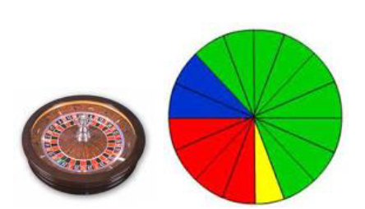
Tournament Method
In this method, two chromosomes are randomly selected from the population and compete in a “tournament.” The one with better fitness wins.
Each chromosome typically participates in two tournaments:
- The best chromosome wins both tournaments
- The worst chromosome loses both
- Medium-quality chromosomes may win one and lose one
As a result:
- The best individuals are selected more frequently
- Average individuals are selected occasionally
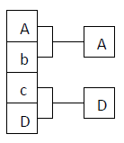
Steady-State Method
This method replaces only a small portion of the population at each iteration, allowing some individuals to survive for multiple generations.
A subset of individuals is selected to produce offspring. The new offspring are then inserted into the population, while some existing individuals are removed to maintain a constant population size.
Two key decisions must be made:
- Which individuals will produce offspring
- Which individuals will be replaced by the new offspring
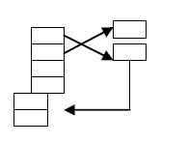
Ranking Method
In this method, all chromosomes are sorted based on their fitness values. A suitable function assigns higher reproduction chances to better individuals, while the worst individuals may not reproduce at all.
This method generally provides a faster search process.
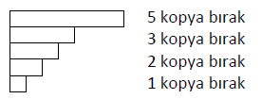
Crossover Operator
The crossover operator is used to increase the diversity and potential of the gene pool by creating new chromosomes with better characteristics than those in the previous generation.
After the reproduction step, two chromosomes are randomly selected from the new population and subjected to crossover.
Crossover is performed by selecting a random point in the chromosome and exchanging genetic material between the two parents.
If an appropriate crossover point is selected, offspring with higher fitness than their parents may be produced. However, since the optimal crossover point is usually unknown, it is chosen randomly.
The main crossover methods are single-point and two-point crossover.

Single-Point Crossover
Chromosomes in the mating pool are randomly paired. For each pair, a crossover point is randomly selected (excluding the first and last gene). All genes after this point are swapped between the two chromosomes.
The chromosomes must have the same length.
Example (crossover at position 3):
P1 = 1,0,0,[1,1,1,1,0] => P1’ =1,0,0,[1,0,0,1,0]
P2 = 1,0,1,[1,0,0,1,0] => P2’ =1,0,1,[1,1,1,1,0]
Two-Point Crossover
In this method, two random crossover points are selected (excluding the first and last genes). The genes between these two points are exchanged.
Example (crossover between positions after gene 1 and gene 5):
P1 = 1,[0,0,1,1],1,1,0 => P1’ =1,[0,1,1,0],1,1,0
P2 = 1,[0,1,1,0],0,1,0 => P2’ =1,[0,0,1,1],0,1,0
PMX Crossover Method (Order-Based):
This method is widely used in problems such as the Traveling Salesman Problem (TSP) and Vehicle Routing Problem (VRP). The reason is that, in these problems, the genes that form a sequence must not repeat within the same sequence. This method prevents such repetitions. Additionally, it preserves a selected substring, which is directly transferred to the offspring. In this method, only one offspring is generated from two parent sequences.
The method works as follows:
Select two parent sequences randomly from the pool, denoted as P1 and P2.
P1 = 1, 2, 4, 6, 3, 7, 5, 8 → suppose the substring 4, 6, 3 is randomly selected.
P2 = 5, 4, 1, 7, 2, 6, 8, 3
The child sequence initially becomes:
C = _, _, 4, 6, 3, _, _, _
Now remove the positions in P2 where the selected genes (4, 6, 3) appear:
P2 = 5, *, 1, 7, 2, *, 8, *
The values 1, 7, 2, which correspond to the positions of the selected substring, are placed into the empty positions (*) in the child sequence:
C = _, 1, 4, 6, 3, 7, _, 2
Finally, the remaining elements (5 and 8) from P2 are placed into their corresponding positions in the child:
C = 5, 1, 4, 6, 3, 7, 8, 2
Thus, one offspring is produced from two parent sequences.
OX Crossover (Order-Based):
This method also prevents repetition of genes within the sequence and follows an order-based structure. Unlike PMX, OX produces two offspring from two parent sequences. Similar to PMX, selected substrings from the parents are preserved and transferred to the offspring.
The method works as follows:
Let us take two parent sequences…
P1 = 1, 3, 5, 7, 9, 2, 4, 6, 8 → let us select the substring [7, 9, 2] from this sequence. Now, find the corresponding substring in the second sequence at the same positions.
P2 = 7, 5, 9, 2, 6, 3, 1, 4, 8 → the substring [2, 6, 3] corresponds to the same positions as above.
These two substrings are transferred to the offspring sequences at the same positions:
C1 = _, _, _, 7, 9, 2, _, _, _
C2 = _, _, _, 2, 6, 3, _, _, _
Next, the parent sequences are reordered starting from the second cut point (the part after the selected substring):
P1’ = 4, 6, 8, 1, 3, 5, 7, 9, 2
P2’ = 1, 4, 8, 7, 5, 9, 2, 6, 3
From the reordered first parent, the substring of the second parent is removed. Similarly, from the second parent, the substring of the first parent is removed:
P1’’ = 4, *, 8, 1, *, 5, 7, 9, *
P2’’ = 1, 4, 8, *, 5, *, *, 6, 3
After removing these positions, the sequences are rearranged:
P1’’’ = 4, 8, 1, 5, 7, 9
P2’’’ = 1, 4, 8, 5, 6, 3
These shortened sequences are then placed into the offspring.
The elements of P1’’’ are inserted into C2 starting from the second cut point (after the substring). Since the first three positions are already filled, when the end of the sequence is reached, insertion continues from the beginning. Similarly, the elements of P2’’’ are inserted into C1.
Final offspring sequences:
C1 = 5, 6, 3, 7, 9, 2, 1, 4, 8
C2 = 5, 7, 9, 2, 6, 3, 4, 8, 1
Thus, two new offspring sequences without repeated elements are obtained.
CX Crossover (Cycle Crossover) (Order-Based):
This method, like the previous two, is also order-based (i.e., no repeated genes in the sequence). In this method, two offspring sequences are produced from each selected parent pair. No crossover point is selected in the parent sequences.
The method works as follows:
Let the parent sequences be:
P1 = 8, 2, 7, 1, 4, 5, 6, 3
P2 = 4, 5, 6, 2, 1, 3, 8, 7
The process starts from the leftmost position of the first parent sequence. The selected genes from each sequence are placed into the offspring.
The first gene is 8. At the same position in the second sequence, there is 4. The number 4 is located at the fifth position in the first sequence. At that position in the second sequence, there is 1. The number 1 is located at the fourth position in the first sequence. At that position in the second sequence, there is 6. The number 6 is located at the seventh position in the first sequence. At that position in the second sequence, there is 8. However, since 8 has already been used, selection from the first sequence stops here.
These identified genes are then placed into the offspring sequences.
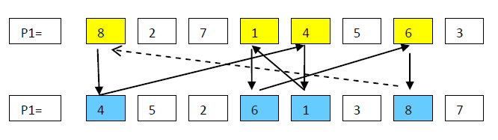
Accordingly, the offspring sequences become as follows:
C1 = 8, *, *, 1, 4, *, 6, *
C2 = 4, *, *, 6, 1, *, 8, *
The remaining positions marked with (*) are then filled by swapping the corresponding elements between the two sequences:
C1 = 8, 5, 2, 1, 4, 3, 6, 7
C2 = 4, 2, 7, 6, 1, 5, 8, 3
Thus, two new offspring sequences are generated from two parent sequences.

LOX Crossover (Linear Order Crossover):
This method is used in job scheduling problems. The sequences are divided into regions at two points and then recombined appropriately to produce new generations.
Tree Crossover:
This method is used when dealing with tree-structured representations (objects with sub-parts). Sub-branches of one tree are cut and inserted into another tree.

Mutation Operator
The crossover operation explores the existing genetic potential. However, if the population does not contain all the encoded information required to solve the problem, a satisfactory solution cannot be reached. Therefore, an operator capable of generating new sequences from the existing gene pool is needed—this is achieved by mutation. In this way, genetic diversity is increased. Mutation can also prevent the algorithm from converging to a local optimum.
Mutation rates are generally kept low to avoid losing high-fitness individuals obtained through crossover.
Bit Flip Mutation:
In simple genetic algorithms, this is performed by changing a value in the sequence from 1 to 0 or vice versa.
P1 = 1, 0, 0, 1, 1, 1, 1, 0
P1’ = 1, 0, 0, 1, 1, 0, 1, 0
Shift Mutation:
A randomly selected block of genes within a sequence is moved to another random position within the same sequence.
P1 = AKDEMZIF
P1’ = AEMZIKDF
Insertion Mutation:
A randomly selected gene in the sequence is inserted into another random position within the same sequence.
P1 = AKDEMZIF
P1’ = ADEMZKIF
Swap Mutation:
Two genes are randomly selected within the sequence and their positions are exchanged.
P1 = AKDEMZIF
P1’ = AZDEMKIF
Termination Criteria
After reproduction, crossover, and mutation operations, a new generation is formed. All these processes are performed in an iterative loop. If no stopping criterion is defined, the process would continue indefinitely.
The following methods are commonly used as termination criteria:
Computation Time Criterion:
In this method, a predefined computation time or number of iterations is set, and the algorithm stops when this limit is reached. However, this approach may have some drawbacks. Further improvements might still be possible if the iterations continue. Additionally, the predetermined number of iterations may be higher than necessary.
Optimization Target Criterion:
In this method, the desired objective function value is known in advance. The algorithm stops when the fitness value reaches this target.
Minimum Improvement Criterion:
In genetic algorithm problems, the best solutions typically improve rapidly at first and then more slowly over time. If the rate of improvement gradually decreases and approaches zero, it may indicate that no further significant improvement can be expected. The algorithm is then stopped by balancing the computation time and the expected solution quality.
5.2. APPLICATION EXAMPLE (TRAVELING SALESMAN PROBLEM)
Let us recall the Traveling Salesman Problem. The objective is to visit each point exactly once and determine the shortest possible route. The same problem appears in electronics as the printed circuit board (PCB) drilling/soldering problem, or in industrial engineering as the asymmetric machine scheduling problem. The fundamental logic is the same in all cases. In this example, we will consider asymmetric paths.
- Binary representation is not suitable for this problem.
- It can be represented using permutation encoding. Each city can be represented by a number.
Let us consider an example with 6 cities. The distances between each pair of cities are given in Table 1. Let the population size be 5. Random values are generated again, and if there are invalid values, they are corrected based on the table. The chromosomes are shown in Table 2.
Tablo 1 Tablo 2
 | 1 | 2 | 3 | 4 | 5 | 6
1 |  | 31 | 43 | 36 | 9 | 50
2 | 36 |  | 11 | 33 | 5 | 17
3 | 27 | 33 |  | 8 | 36 | 44
4 | 14 | 6 | 9 |  | 46 | 29
5 | 12 | 15 | 39 | 45 |  | 37
6 | 24 | 6 | 37 | 43 | 37
kromozom1 | 1 | 2 | 3 | 4 | 5 | 6
kromozom 2 | 4 | 1 | 6 | 3 | 5 | 2
kromozom 3 | 3 | 6 | 1 | 4 | 5 | 2
kromozom 4 | 5 | 2 | 1 | 3 | 4 | 6
Kromozom 5 | 1 | 2 | 5 | 4 | 3 | 6

According to Table 3, the shortest distance belongs to Chromosome 1.
.
Tablo 3
 | Şehirler arası mesafeler |  |  |  |  |  | Toplam Mesafe
kromozom1 | 31 | 11 | 8 | 46 | 37 | 24 | 157
kromozom 2 | 14 | 50 | 37 | 36 | 15 | 33 | 185
kromozom 3 | 44 | 24 | 36 | 46 | 15 | 11 | 176
kromozom 4 | 15 | 36 | 43 | 8 | 29 | 37 | 168
Kromozom 5 | 31 | 5 | 45 | 9 | 44 | 24 | 158

Another alternative representation method is Random Keys encoding. In this approach, solutions are encoded using random numbers between 0 and 1. For example, a chromosome such as:
[0.23, 0.82, 0.45, 0.75, 0.87, 0.11, 0.56, 0.69, 0.78]
represents a sequence where the i-th gene corresponds to the i-th city. The random value at each gene position indicates the visiting order of that city. After sorting these values, a permutation such as:
[6, 1, 3, 7, 8, 9, 2, 5]
is obtained.
Here, the smallest value is 0.11, which corresponds to the 6th position in the random sequence. Therefore, the 6th city is visited first.
Using this idea, the same population is generated using the Random Keys method.
It is assumed that random numbers are always unique, with no two values being equal. The chromosome table generated using a randomization function is given in Table 4.
Note: Although the values may appear identical, the decimal parts beyond the third digit are always different. It is not possible for two values to be exactly the same, which is one of the advantages of this method.
Looking at Chromosome 1, the smallest value in the first row is 0.05. Therefore, the first city to be visited is City 2.
At this stage, Table 4 must be converted into real numerical values. The representation using real numbers is given in Table 5.
 | 1 | 2 | 3 | 4 | 5 | 6
kromozom1 | 0.49 | 0.05 | 0.73 | 0.32 | 1 | 0.78
kromozom 2 | 0.05 | 0.03 | 0.69 | 0.23 | 0.13 | 0.76
kromozom 3 | 0.63 | 0.3 | 0.3 | 0.74 | 0.63 | 0.07
kromozom 4 | 0.83 | 0.77 | 0.9 | 0.91 | 0.01 | 0.99
Kromozom 5 | 0.98 | 0.71 | 0.69 | 0.1 | 0.08 | 0.8
Table 4

 | 1 | 2 | 3 | 4 | 5 | 6
kromozom1 | 3 | 1 | 6 | 2 | 6 | 5
kromozom 2 | 2 | 1 | 5 | 4 | 3 | 6
kromozom 3 | 4 | 3 | 2 | 6 | 5 | 1
kromozom 4 | 3 | 2 | 4 | 5 | 1 | 6
Kromozom 5 | 6 | 4 | 3 | 2 | 1 | 5
Tablo 5

Tablo 5’e göre toplam mesafeleri yine Tablo 1’deki mesafelerden yararlanarak düzenleyecek olursak:
 | Şehirler arası mesafeler |  |  |  |  |  | Toplam Mesafe
 | 1 | 2 | 3 | 4 | 5 | 6
kromozom1 | 27 | 36 | 6 | 17 | 37 | 39 | 162
kromozom 2 | 36 | 9 | 45 | 9 | 44 | 6 | 149
kromozom 3 | 9 | 33 | 17 | 37 | 12 | 36 | 144
kromozom 4 | 33 | 33 | 46 | 12 | 50 | 37 | 211
Kromozom 5 | 43 | 9 | 33 | 36 | 9 | 37 | 167

NOTE: While permutation representation directly represents the solution, random key encoding is more suitable for single-point crossover and gene-based mutation operations.
Let us try single-point crossover:
For x-over k1 and k2: let it be 3. This means that for the 1st and 2nd chromosomes, crossover will be performed after the 3rd gene. For this purpose, we use the first two columns of Table 2.
Table 6.
kr1 | 1 | 2 | 3 | 4 | 5 | 6 | Yeni kr1 | 1 | 2 | 3 | 3 | 5 | 2 | Düzeltilmiş kr1 | 1 | 2 | 3 | 6 | 5 | 4
kr2 | 4 | 1 | 6 | 3 | 5 | 2 | Yeni kr2 | 4 | 1 | 6 | 4 | 5 | 6 | Düzeltilmiş kr2 | 4 | 1 | 2 | 3 | 5 | 6

The new kr1 and kr2 rows contain repeated values, and some values (i.e., cities) are missing. This is an undesired situation and results in an invalid solution. Therefore, these values need to be corrected.
Let us apply mutation in permutation representation:
For example, let us change the 2nd gene of the 3rd chromosome to 3.
Table 7
kr3 | 3 | 6 | 1 | 4 | 5 | 2 | Mutasyona uğramış kr2 | 3 | 3 | 1 | 4 | 5 | 2

This also produces an invalid (illegal) solution. Of course, this can be corrected. However, by applying crossover and mutation in permutation representation, we have demonstrated the disadvantage of this method.
Now let us apply crossover and mutation using the random key representation:
We take the values of Chromosome 1 and Chromosome 2 from Table 4 and again perform crossover after the 3rd gen
Table 8
 | 1 | 2 | 3 | 4 | 5 | 6 |  | 1 | 2 | 3 | 4 | 5 | 6
kr1 | 0.49 | 0.05 | 0.73 | 0.32 | 1 | 0.78 | Yeni kr1 | 0.49 | 0.05 | 0.73 | 0.23 | 0.13 | 0.76
kr 2 | 0.05 | 0.03 | 0.69 | 0.23 | 0.13 | 0.76 | Yeni kr2 | 0.05 | 0.03 | 0.69 | 0.32 | 1 | 0.78

Note: Here, we again convert the decimal values into a meaningful representation, i.e., determining which city is visited in which order (Table 9). While doing this, the rank of the smallest value in each row is assigned as 1.
Table 9
 | 1 | 2 | 3 | 4 | 5 | 6
Düzenlenmiş kr1 | 4 | 1 | 5 | 3 | 2 | 6
Düzenlenmiş kr2 | 2 | 1 | 4 | 3 | 6 | 5

If mutation is applied randomly:
Let us assume that the 2nd gene in Chromosome 1 is changed. Since these are random values, the change is also performed using a random function. We take the chromosome values from Table 8.
Table 10
 | 1 | 2 | 3 | 4 | 5 | 6 |  | 1 | 2 | 3 | 4 | 5 | 6
kr1 | 0.49 | 0.05 | 0.73 | 0.23 | 0.13 | 0.76 | Mutasyon sonrası kr1 | 0.49 | 0.76 | 0.73 | 0.23 | 0.13 | 0.76
 |  |  |  |  |  |  | Düzenlenmiş kr1 | 3 | 6 | 4 | 2 | 1 | 5
 |  |  |  |  |  |  | Mutasyon öncesi sıralama | 4 | 1 | 5 | 3 | 2 | 6

Note: As seen, when values are generated using the random key method, no illegal or invalid solutions are produced.
5.3. SOLAR ENERGY TEST PROBLEM
Let us consider the solar energy test problem (see Problem 8 in Section 1). In this problem, it is required to minimize the following cost function, where the decision variable is temperature $T$, which is constrained between 40°C and 90°C:
$$U(T)=-204.165+5.330 T-0.0104 T^{2}$$
Each step of the GA will be explained using this solar energy test problem.
5.3.1 Initialization of the Population
The variable $T$must be restricted to the interval $\left[40 , 90\right]$. Since $T$is encoded as a binary string, the number of bits (i.e., the chromosome length) must first be determined. Because each bit can take the value 0 or 1, a 5-bit string corresponds to a minimum value of 00000 and a maximum value of 11111.
In decimal representation, these correspond to 0 and 32 respectively ($2^{5}$).
When this range is linearly mapped to the search space, the resolution (precision) of the variable $T$becomes:
$$\frac{90-40}{2^{5}-1}={1.5625}^{∘}C$$
However, since a higher precision such as 0.001°C is required for the variable $T$, a chromosome length of 15 bits is needed. The variables in the initial population (in binary form) are generated randomly. For this purpose, a uniform random number generator that produces values between 0 and 1 can be used. If the generated random number is less than 0.5, the bit value is set to 0; otherwise, it is set to 1. To generate a binary string of length 15, the same number of random values must be produced.
The following random numbers were generated using the MATLAB® rand command. The corresponding bit string is given in the second row:
0.81 0.90 0.13 0.91 0.63 0.09 0.28 0.54 0.96 0.15 0.35 0.47 0.74 0.19 0.80
1 1 0 1 1 0 0 1 1 0 0 0 1 0 1
Accordingly, the first individual in the population is:
110110011000101
This step is repeated for the number of individuals in the population. When the population size is taken as 10, the following strings are randomly generated:
However, since a higher precision such as 0.001°C is required for the variable $T$, a chromosome length of 15 bits is needed. The variables in the initial population (in binary form) are generated randomly. For this purpose, a uniform random number generator that produces values between 0 and 1 can be used. If the generated random number is less than 0.5, the bit value is set to 0; otherwise, it is set to 1. To generate a binary string of length 15, the same number of random values must be produced.
The following random numbers were generated using the MATLAB® rand command. The corresponding bit string is given in the second row:
0.81 0.90 0.13 0.91 0.63 0.09 0.28 0.54 0.96 0.15 0.35 0.47 0.74 0.19 0.80
1 1 0 1 1 0 0 1 1 0 0 0 1 0 1
Accordingly, the first individual in the population is:
110110011000101
This step is repeated for the number of individuals in the population. When the population size is taken as 10, the following strings are randomly generated:
110110011000101
100001010111010
000110101110101
100000110011101
000011100100111
100100101011000
010110100110001
100110101110011
111100100011010
001111100111001
In the next step, these binary strings are decoded to calculate their fitness values.
5.3.2 Fitness Evaluation
The binary string (genotype) must be converted into a real value (phenotype) using the following equation:
$$\begin{matrix} & T_{i}=T_{i,min⁡}+\frac{\left(T_{i,max⁡} − T_{i,min⁡}\right)}{\left(2^{l_{i}} − 1\right)} DV(s_{i}) & & \text{(5.1)}\end{matrix}$$
where:
- $T_{i,min⁡}$and $T_{i,max⁡}$are the lower and upper bounds of the variable $T_{i}$,
- $DV(s_{i})$is the decimal value of the decoded binary string $s_{i}$,
- $l_{i}$is the length of the binary string used to encode the $i$-th parameter.
For example, the binary string 110110011000101 can be decoded as follows:
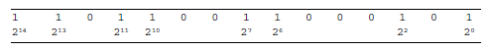
Assuming the leftmost bit is the most significant bit (MSB), the decimal value of the binary string is:
$$2^{14}+2^{13}+2^{11}+2^{10}+2^{7}+2^{6}+2^{2}+2^{0}=27,845$$
The corresponding value of the variable is then calculated as:
$$T_{i}=T_{i,min⁡}+\frac{\left(T_{i,max⁡} − T_{i,min⁡}\right)}{\left(2^{l_{i}} − 1\right)} DV(s_{i}) \\ =40+\frac{\left(90 − 40\right)}{\left(2^{15} − 1\right)}×27,845 \\ =82.4894$$
The fitness value of this string is obtained by substituting $T_{i}=82.4894$into the objective function:
$$f(T_{i})=-204.165+5.330 T_{i}-0.0104 T_{i}^{2}=1403.6$$
Table 5.1 summarizes the decoded values and fitness values of all 10 strings in the population.
5.3.3 Reproduction
During the reproduction stage, good and bad chromosomes (strings) are identified according to their fitness values. Chromosomes with higher fitness values are given more copies in the next generation, while weaker ones are eliminated. This process can be carried out using methods such as roulette wheel selection or tournament selection.
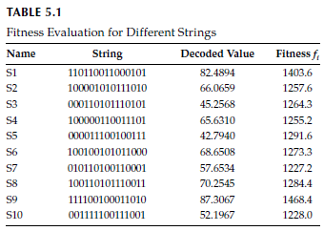
In the first method, the size of each slice on the roulette wheel is proportional to the fitness value of each individual. The wheel is spun, and the indicated individual is selected. This process is repeated until the entire population is filled.
The roulette wheel selection method is suitable for maximization objective functions. However, since the objective function in this test problem is to be minimized, the fitness values must be properly transformed in order to apply the roulette wheel method. This transformation is carried out in two steps.
In the first step, it is checked whether there are any negative values among the fitness values. If so, the smallest value is identified, and the other fitness values are scaled accordingly. For example, if the fitness values are –5, –1, 2, and 7, after scaling they become 0, 4, 7, and 12, respectively.
In the second step, the fitness values $f_{i}$are transformed into $F_{i}$using the following equation:
$$F_{i}=\frac{1}{1+f_{i}} (5.2)$$
In this case, the fitness values 0, 4, 7, and 12 are transformed into 1, 0.2, 0.1429, and 0.0833, respectively.
Since there are no negative fitness values in the test problem, the first step can be ignored, and the $F_{i}$fitness values and some other terms can be calculated as shown in Table 5.2.
Let us draw a pie chart corresponding to the data in the last column of Table 5.2. For the next generation, the 7th and 10th individuals, denoted as S-7 and S-10, have the highest selection probability (11%). The next step in the selection process is to construct the roulette wheel slices (Figures 5.3 and 5.4) using the cumulative sums of the values in the last column of the table.
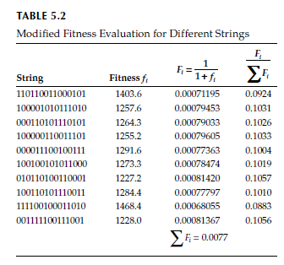
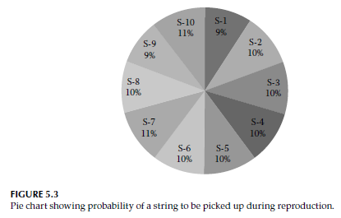
Ten random numbers between 0 and 1 are generated (corresponding to the population size), and the individuals are selected based on which slice of the roulette wheel these numbers fall into. As a result of this reproduction process, two copies each of individuals S-2, S-7, and S-8, and one copy each of individuals S-4, S-5, S-6, and S-10 are obtained. These individuals will participate in the crossover and mutation operations.
The convergence speed of a Genetic Algorithm (GA) largely depends on the selection pressure (i.e., the extent to which better individuals are favored). Increasing the selection pressure generally leads to better convergence. However, if the selection pressure is too high, the likelihood of the GA prematurely converging to a non-optimal (suboptimal) solution increases. The roulette wheel selection method is known for providing high selection pressure, which often leads to premature convergence.
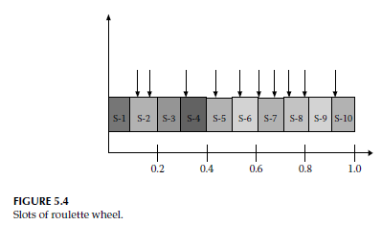
An alternative method is tournament selection. In this method, a certain number of individuals (for example, two) are randomly selected from the population, and the individual with the best fitness value within this group is chosen as a parent. This process is repeated once for each individual in the new population. This method guarantees that the best solution is always preserved, while the worst solution is always eliminated from the selection process.
An important point to note is that while roulette wheel selection is used for maximization-type objective functions, tournament selection is used for minimization-type objective functions. Since the objective function in the test problem is of a minimization type, the fitness function had to be appropriately transformed for the roulette wheel selection method. In contrast, no such transformation is required for the tournament selection method, as the objective function is already of a minimization type.
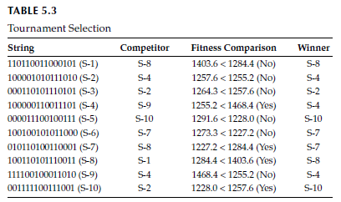
In the tournament selection method, the process starts with the first individual in the population. Then, another individual is randomly selected from the population. The fitness values of these two individuals are compared, and the individual with the lower fitness value is declared the “winner.” This process is repeated for all individuals in the population. All winners are selected for crossover and mutation operations, which are the next steps of the Genetic Algorithm (GA). Table 5.3 illustrates the tournament selection method for the test problem.
5.3.4 Crossover and Mutation
In the reproduction step of the Genetic Algorithm (GA), the sequences that will participate in crossover and mutation operations are only copied; no modification is applied to the sequences at this stage. In the crossover operation, two parents are randomly selected from the mating pool (obtained in the previous step of the GA via roulette wheel or tournament selection), and bit exchange is performed between the parents to generate new offspring (sequences). The basic idea behind crossover is that good parents mate to produce better offspring.
Let us consider the S-2 and S-4 sequences randomly selected as parents from the mating pool (both of which appear in the selection procedures obtained via both roulette wheel and tournament selection). The next step is to randomly determine a crossover point along the sequence length. Assume that, when counted from the left (most significant bit), the ninth bit is chosen as the crossover point. In this case, after crossover, the S-2 and S-4 sequences become:
Parent S-2: 100001010 | 111010 → 100001010 | 011101
Parent S-4: 100000110 | 011101 → 100000110 | 111010
In this process, a single-point crossover is assumed. It is known that in nature, crossover can occur at one or multiple points. The number of crossovers follows a Poisson distribution with a mean of 2 (Hartl, 1991).
The mutation process is used to maintain diversity in the population. The mutation operator flips a bit value from 1 to 0 or from 0 to 1 with a small probability.
For the test problem, let us apply single-point crossover and a mutation probability of 0.02 on the mating pool obtained using tournament selection. The resulting new population is given in Table 5.4.
This process completes one generation of the GA. Then, the fitness values of the new population are calculated and the cycle (reproduction, crossover, and mutation) is repeated. In GA, it is possible that no improvement in the objective function occurs over several successive generations.
The mathematical description of GA is given by the Schema Theorem:
$$m(H,t+1)≥m(H,t) \frac{f(H)}{\overset{ˉ}{f}}\left(1 − p_{c}\frac{δ(H)}{l-1}\right)(1-p_{m})^{o\left(H\right) }(5.3)$$Here:
- $m(H,t)$denotes the number of instances of a specific schema $H$at time $t$,
- $f(H)$represents the average fitness of the strings represented by schema $H$,
- $\overset{ˉ}{f}$denotes the average fitness of the entire population,
- $p_{c}$and $p_{m}$denote the probabilities of crossover and mutation, respectively,
- $δ(H)$represents the defining length of schema $H$(the distance between the first and last fixed bit positions),
- $o(H)$represents the order of the schema (the number of fixed bits),
- $l$denotes the length of the string.
The Schema Theorem states that short, low-order schemas with above-average fitness receive an increasing number of trials in subsequent generations.
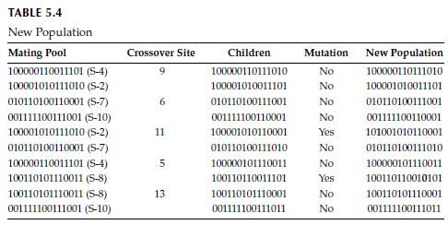
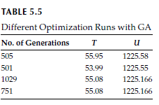
The main program of the genetic algorithm is the MATLAB code named prob.m. Its subprograms are provided in the files in.m, roulette.m, tournament.m, and func.m. When the genetic algorithm code is executed for the test problem, the obtained output is shown in Table 5.5. Each row in the table corresponds to a separate optimization run.
As can be seen from Table 5.5, in most runs the minimum values are reached. However, the required number of generations differs in each run. This is an expected result, since each run of the genetic algorithm starts with a randomly generated initial population. In Figure 5.5, the minimum objective function value obtained up to the corresponding generation is plotted. The step-like regions in the graph indicate that there is no improvement in the objective function value over a certain number of generations, while at a specific generation a sudden drop in the objective function value occurs.
5.3.5 Multimodal Test Functions
One of the most important advantages of genetic algorithms (GA) over gradient-based methods is that they do not get trapped in local optima. To demonstrate this property of GA, let us consider some multimodal test functions such as Rastrigin and Schwefel functions and show that GA can find the global minimum for these functions.
The two-variable Rastrigin function (see Figure 5.6) is defined as follows:
$$f\left(x_{1},x_{2}\right)=20+x_{1}^{2}-10\cos\left(2πx_{1}\right)+x_{2}^{2}-10\cos\left(2πx_{2}\right),-5.12≤x_{1},x_{2}≤ 5.12$$
This function has a large number of local optima. The global minimum value of the function is:
$$f(x^{*})=0$$
and it occurs at:
$$x^{*}=(0,0)$$
This function can be plotted using the following MATLAB commands.
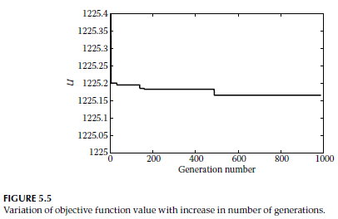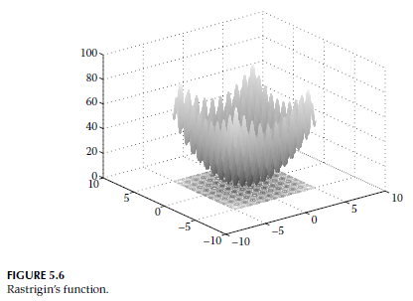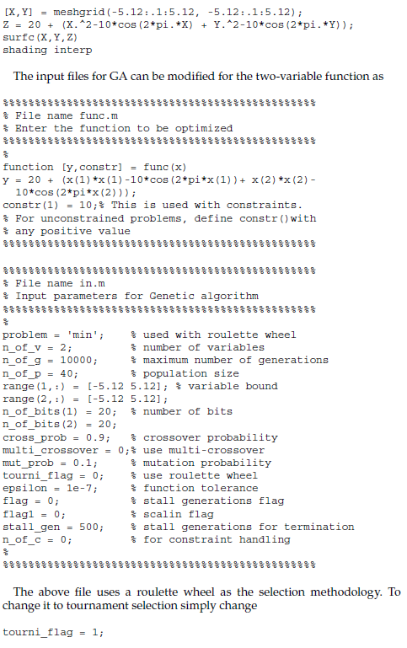
The file given above uses the roulette wheel approach as the selection method. To convert this into tournament selection, it is sufficient to make only the following change:
tourni_flag = 1;
Both selection methods are able to find the global minimum solution. In addition, the convergence behavior of the two selection methods toward the optimum value is shown in Figures 5.7 and 5.8, respectively.
The two-variable Schwefel function (see Figure 5.9) is defined as follows:
$$f(x_{1},x_{2})=-x_{1}sin⁡(\sqrt{∣x_{1}∣})-x_{2}sin⁡(\sqrt{∣x_{2}∣}),-500≤x_{1},x_{2}≤500$$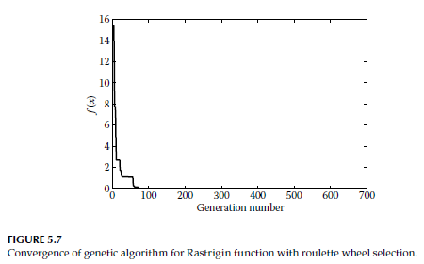
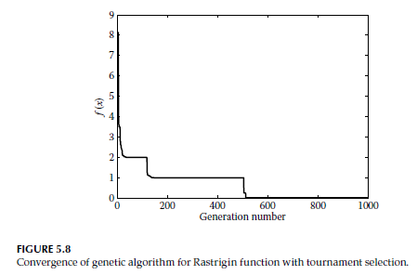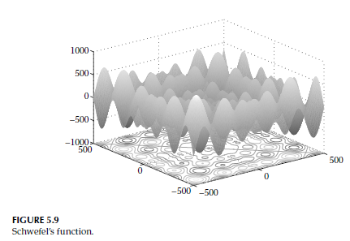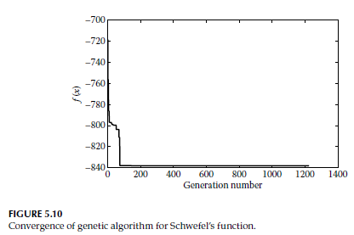 This function has a large number of local optima, and the global minimum value of the function is given by
$$f(x^{*})=-837.9658$$
and it occurs at
$$x^{*}=(420.9867, 420.9867)$$
The input files used for the Genetic Algorithm (GA) can be modified as follows to make them suitable for the two-variable function.
